Green Roofs (J. Johnston & J. Newton, Building Green pp 47-72)

- Amenity benefits
Stuttgart’s 1989 Law of Building Book now requires the installation of grass roofs on flat-roofed industrial buildings. 1989 there were estimated one million sq.m. of low-maintenance grass roofs. Theses areas can be less noisy and provide ‘retreat’ space. Can also provide food.

- Ecological benefits
Not all wildlife can accommodate these areas but they are subject to less disturbance. Butterflies will visit gardens located as high as 20 stories.
Soils can be 5-10ºC. warmer than those at ground level in summer but significantly colder in winter.
It has been shown that where temperature fluctuations are strong, vegetation adapted to cope has a better chance of survival. Soil temperatures vary greatly due to aspect and depth of soil.

- Technical & financial benefits
Soil and plants keeps damaging influences away. The average flat roof has a life expectancy of 10-15 years cf. Derry & Toms green roof installed in 1938 still going strong in Kensington High Street.
UV protection; asphalt and bitumen heat up rapidly. The difference can be 80 to 27ºC. It means reduced stresses on building materials.
Soil and plants can weigh no more than a gravel roof.
Insulation in winter compared to a gravel roof can be as much as 7ºC. Grass is the best insulator. Summer insulation as much as 10%
Roof space may mitigate planning and building problems on ground level.
Retrofitting is always more costly. But designing from the onset savings on structural elements may even reduce costs.
Extensive roofs can be as much as 80% cheaper than an intensive roof.
Costs for the DIY enthusiast can be about twenty pound per square meter (1987), professionally fifty pounds. A tiny levy on a block of flats could offset installation and maintenance costs.

- Environmental benefits
Improves urban climate; absorbs stormwater, up to 75% of the surface rain; aesthetic.

Problems may include wind damage. Can be mitigated by stepped or terraced buildings as well as vegetative planting cf. Mountbatten House, Basingstoke.
Irrigation may need to be applied between March and September.

  - Methodology

Intensive (traditional) or roof gardens
Intensive management
200mm of soil or more
Irrigation system
Diversity of species
Seating area
Capable of many styles

Extensive (ecological)
Soils as little as 50mm
Not recreational
Low weight can be used on existing structures
Suitable for roofs up to 30º

Earth shelters
Continuous layer between ground and the roof
Running costs are between 40 and 70% of those above ground due to insulation qualities of the soil

Soils
An appropriate mixture should be chosen with reference to climate, location, species and load bearing capacity.
Pure sand can be used with stonecrop. Plants are induced to root and then the system is self-maintaining.
Crushed rubble can be used to supplement organic material also. They also prevent unwanted weed seeds. Nutrient levels will increase with humus production and nutrients carried in the rain. Brown roofs utilize waste materials.
A low fertility mulch will retain moisture levels.
Drainage & load
Flat roofs demand drainage and can be effected using a particular substrate. On a sloping roof a gravel-filled pipe will draw away the excess water.
Roof calculations must include dead- and live-loads. Waterproofing material is generally lightweight but should be calculated, as should snowfall in particular climes and maintenance machinery/persons.
Some gravel or tile roofs will spontaneously evolve mosses, grasses, succulents and certain herbaceous without any substantial weight increase. Moss is tolerant of many conditions and can fully establish after four years if interspaced 150mm centers.
Ponds or water features are suited only to intensive roof gardens, but encourage greater diversity.
Planting
Most favorable time is October to March, April to June in very cold areas.
Turfs can be interplanted with loose seed in order to establish soil stability.
Inclined roofs of 8 to 10º and above are best planted with turf, across the ridge and down the sloping side of the roof. Plugs also are the best option here.
Drought resistant plants are favorable and a mix of such will colonize any gaps.
Intensive roofs favor the incorporation of wildlife-friendly plants, including nectar plants, fruits, nuts and seeds.
Wet-preferring herbs may colonize at the bottom edges.
Maintenance
Extensive roofs require little, other than the removal of tree saplings and watering during drought.
It is vital to install artificial irrigation for intensive roofs. Water can be stored in tanks and collected from runoff. Systems can run off solar energy on a 12v battery also.
Easy access is required for every type of roof.
Grassland areas can be managed as hay meadows, cut once a year.
Lawns may be top dressed once a year and mown at intervals. Animals can also be incorporated, for instance ducks and geese.

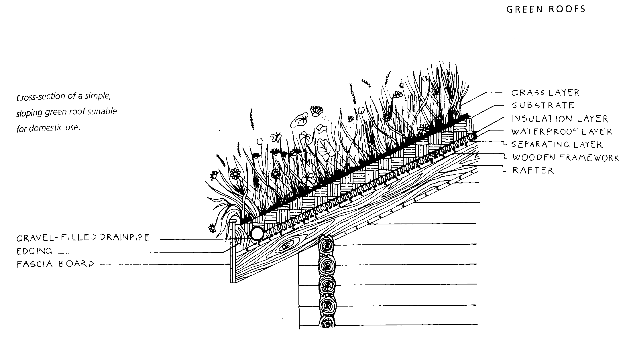

My roof is slightly more insulated. As follows:

Gravel-buried drainpipe

Proposed vegetation layer 1”
Top soil (sandy) 4”
Underlay
Plastic waterproof liner
Carpet ½”
Damp proofer
Fascia boards 1 X 6”
Ply board 1”
Rafter

Top elevation

11’1”
13’1”
18’8”
15’9”

12’

13’

Calculating loads for saturated soil

Sandy soil with gravel drainage 18kg/m² per centimetre in depth
Total area = 4.7m x 4.1m = 19.3m² (4.4m)²

Depth of soil = 12cm

Weight of saturated soil = 18 x 4.4 x 12 = 950.4kg
Estimated weight of underlay, liners and carpets = 50kg
Estimated weight of seasoned timber, fascia boards, ply and joists = 200kg
Estimated weights of fixtures and fittings = 3kg

Total weight calculation = 1,253.4kg x possible error deficit = 1.5t

As for windage you need to seek specialist advice. But no books I have read mention it. Bearing in mind that I have included a possible error deficit the final figure attained I believe is a workable calculation.

Johnston, J, & Newton, J. Building Green p62

